USE CASE DIAGRAMS ON NSA RESTAURANT

Trae Watkins

Bradford Smith

Nicholas Chard

Dustin Fennessy

Bikash Munikar

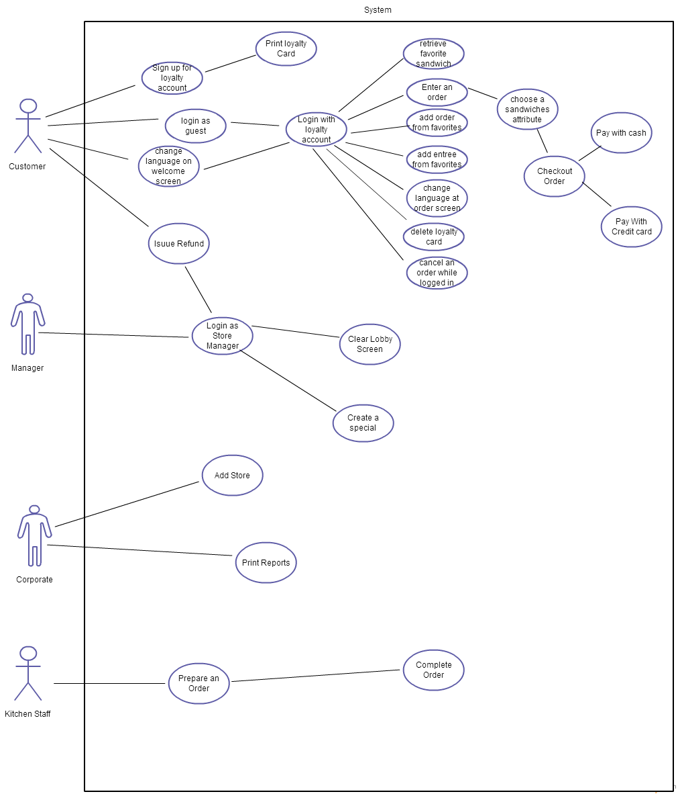

## Use Cases:

1. Name: Loyalty Signup

Actors:

1. Customer
2. System

Entry Conditions:

1. Customer is at startup screen.
2. User clicks signup button.
3. Customer does not have loyalty account.

Exit Conditions:

1. Account is created.
2. System moves to order screen.

Event Flow:

1. Customer clicks signup button.
2. Customer fills out sign up form.
3. Customer clicks complete button.
4. System dispenses loyalty card.

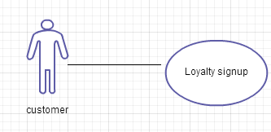

2. Name: Add entrees from favorites

Actors:

1. Customer System
2. System

Entry Conditions:

1. Customer is at loyalty account screen.
2. Customer has at least one favorite entrée saved.

Exit Conditions:

1. System adds selected favorite entrée to current order.

Event Flow:

1. Customer selects a favorite entrée.
2. Customer clicks add to order button.

3. System adds the selected favorite entrée to the current order

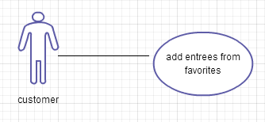

3. Name: Add Order from Favorites

Actors:

1. Customer
2. System

Entry Conditions:

1. Customer is at loyalty account screen.

2. Customer has at least one favorite order saved.

Exit Conditions:

1. System adds all items of the selected favorite order to current order.

Event Flow:

1. Customer selects a favorite order.

2. Customer clicks add to order button.

3. System adds all items of the selected favorite order to the current order.

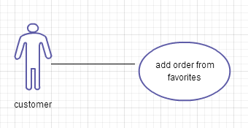

4. Name: Delete Loyalty Account

Actors:

1. Customer
2. System

Entry Conditions:

1. Customer has a loyalty account.
2. Customer is logged into loyalty account.
3. Customer is at loyalty account screen.
4. Customer clicks delete loyalty account button.

Exit Conditions:

1. Loyalty account is deleted.
2. System sends Customer to startup screen.

Event Flow:

1. Customer logs into loyalty account.
2. Customer clicks loyalty account tab.
3. Customer clicks delete loyalty account.
4. System deletes loyalty account.

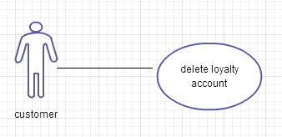

5. Name: Complete Order

Actor: Kitchen Employee

Entry Condition:

1. Order on Kitchen Display

2. Order is completed and ready.

Flow Events:

1. User looks at order on screen and reads the number at the bottom of the column that the order is in.

2. User presses the corresponding number on the keypad.

Exit Condition: Order is cleared from Kitchen Display.

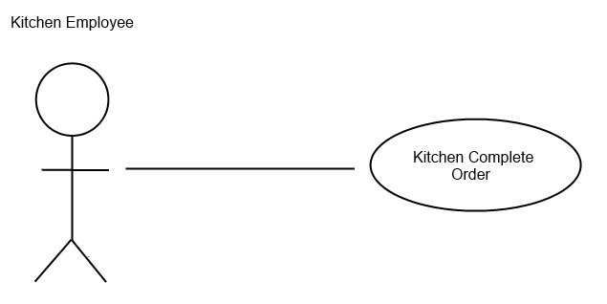

6. Name: Clear Lobby Screen

Actor: Store Manager or Assistant Manager

Entry Condition:

1) Order listed on the lobby display screen.

2) Orders listed are old and need to be removed.

3) Manager is logged into the manager application.

Flow Events:

1. Manager goes to the “Tools” tab.
2. Manager clicks the “Clear Orders” button.

Exit Condition: Lobby Screen is cleared.

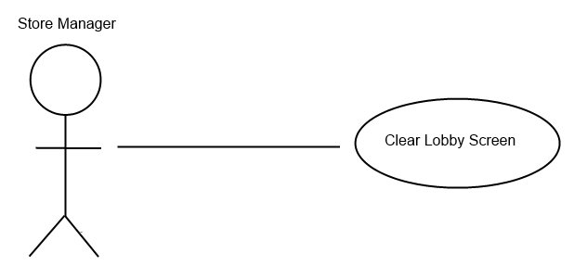

7. Name: Print Reports

Actor: Corporate User

Entry Condition:

1) Corporate Database was updated night before.

2) User is logged into the corporate application.

Flow Events:

1. User goes to the “Reports” tab.
2. User selects the stores they want to run the reports for.
3. User selects the desired report.
4. User clicks the “Print Report” button.
5. The standard windows print dialog opens.
6. User clicks the print button

Exit Condition: The desired report for the selected stations is printed.

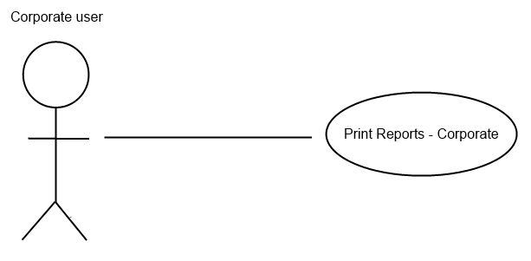

8. Name: Add Store

Actor: Corporate User

Entry Condition:

1) Corporate Database was updated night before.

2) User is logged into the corporate application.

3) User knows Address of the new store.

Flow Events:

1. User goes to the “Stores” tab.
2. Enters the new store’s information in the appropriate fields.
3. User clicks the “Save/Update” button

Exit Condition: The system finds the next available store number and creates the new store using the next number.

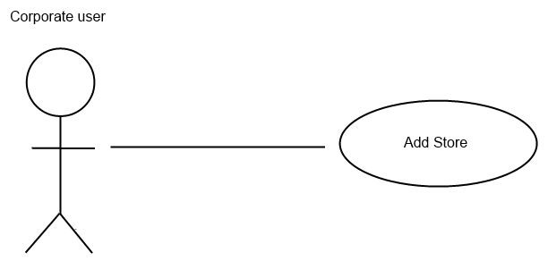

9. Name: Login as a Store Manager

Actors: Store Manager

Entry Condition:

1. He/she must enter the username and password before entering.
2. The username and password must be valid.

Flow Event:

1. The store manager is given username and password while getting appointed.
2. The username and password must be unique.
3. The manager looks at screen and enters the username and password to successfully log in.
4. The manager presses log out button to exit.

Exit Condition:

1. He/she must hit the log out button which is available in every page after he/she logs in.

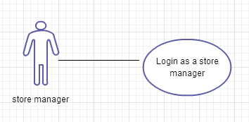

10. Name: Entering an order

Actors: Customer

Entry Condition:

1. Customer presses the button ready to order.

2. Customer also can use loyalty card to login to their accounts

Flow Condition:

1. Customer either login as an account holder or as a guest account.

2. The customer looks on screen and chooses the various bread and stuffing they would like.

Exit Condition:

1. The customer can cancel the order in the mid way or checkout order to exit.

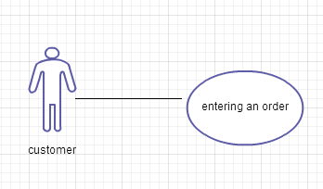

11. Name: Credit Card Payment

Actors: Customer

Entry Condition:

1. After entering their order, customer will be allowed to choose their way of payment cash, credit.

Flow Event:

1. Customer orders their food.

2. Customer hits the checkout button (Note: the total amount of bill will be shown at the right side of the screen at all time).

3. Customer can pay using credit card swiping them in the machine attached to the terminals.

Exit Condition:

1. Customer takes their receipt and wait for the food.

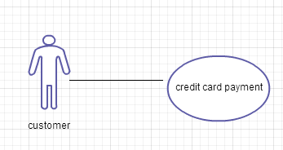

12. Name: Prepare an order

Actors: Kitchen Staff

Entry Condition:

1. After customer place the order, the items are printed on to the kitchen screen.

Flow Event:

1. The orders are printed on to the screen according to the time that the order has been placed.

2. The kitchen staff reads the order and prepares the order in the same order it is ordered.

3. The kitchen staffs announce the readiness of the food to the supplier and he/she supplies it to the front desk.

Exit Condition:

1. The kitchen clears the ready order screen and work on another order.

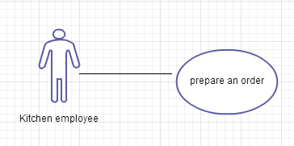

13. Name: Changing the language at the order screen

Actor: Customer, System

Entry Condition:

1. Customer is at the order screen

2. Customer wants to change the language

Exit Condition:

1. Customer changes the language

Event flow:

1. Customer clicks on the language tab

2. Customer clicks on the language they want the program in

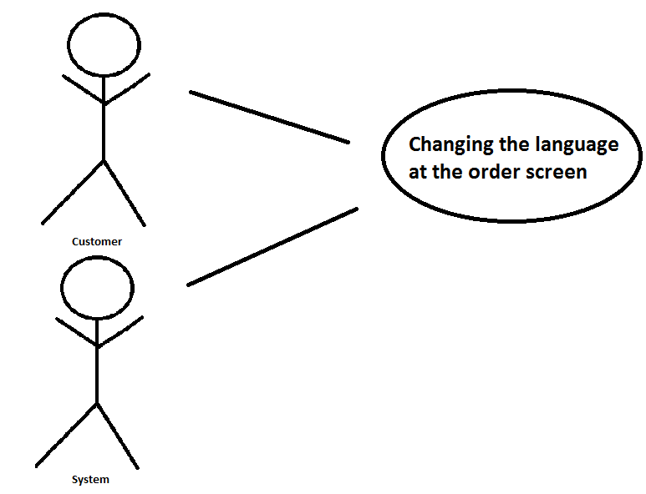

14. Name: Logging in with a loyalty card

Actor: Customer, System

Entry Condition:

1. Customer has their loyalty card

2. Customer is at the login screen

Exit Condition:

1. Customer swipes their loyalty card

Event flow:

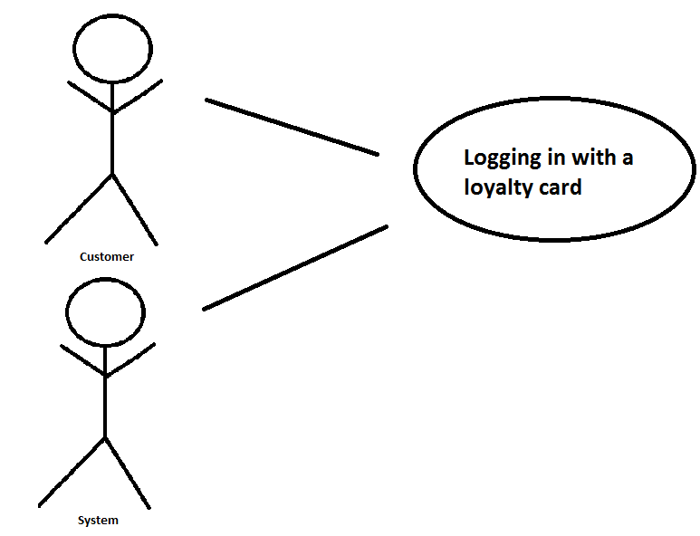1. Customer swipes their loyalty card

15. Name: Refunding an order to a customer

Actor: Customer, Manager, System

Entry Condition:

1. Customer wants a refund on an order

2. Manager is willing to give the customer a refund

Exit Condition:

1. Manager issues refund to customer

Event flow:

1. Manager finds order on the manager kiosk

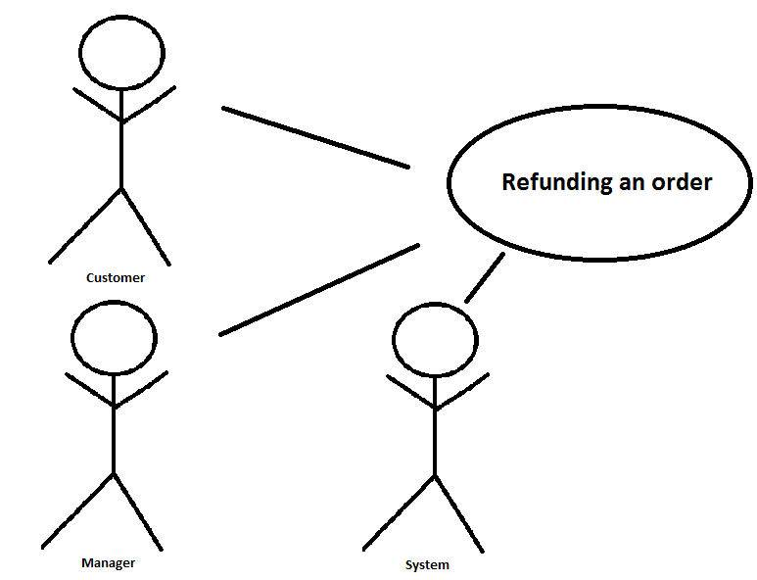2. Manager issues refund to customer

16. Name: Manager creating a special

Actor: Manager, System

Entry Condition:

1. Manager is at the menu items screen on the manager kiosk

2. Manager wants to create a new special

Exit Condition:

1. Manager saves the new special

Event flow:

1. Manager chooses a name for the special

2. Manager chooses a category for the special

3. Manager chooses a price for the special

4. Manager chooses the specials components

5. Manager chooses the days of the week and the dates the special is

6. Manager clicks on save to save the special

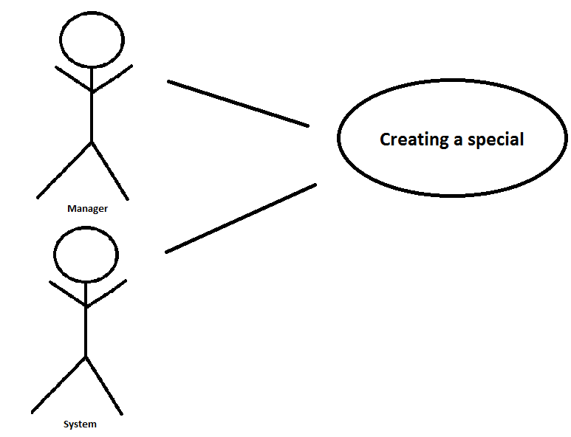

17. Name: Cancelling an order while logged into a loyalty account.

Actors: Customer, Customer Interface

Entry Condition: User is signed into a loyalty account and an order is in progress.

Flow Event:

1. The user presses the “Cancel Order” button

2. The system clears the user’s list of items to order

3. The system logs the user out of his or her loyalty account

Exit Condition: No user is logged in and the system is displaying the welcome screen

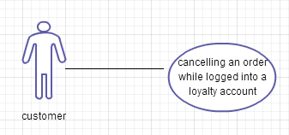

18. Name: Choosing a new attribute for a sandwich

Actors: Customer, Customer Interface

Entry Condition: The customer is making an order.

Flow Event:

1. The customer presses the button corresponding to their new choice.

2. The system clears the old choice

3. The system stores the new choice as part of the order

Exit Condition: The system is displaying the new choice

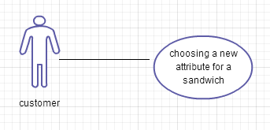

19. Name: Logging as a guest user

Actors: Customer, Customer Interface

Entry Condition: The customer does not have an existing account and the system is displaying the welcome screen

Flow Event:

1. The customer presses order as a guest.

2. The system logs them to guest user.

3. The system begins a new order

Exit Condition: The customer checks out.

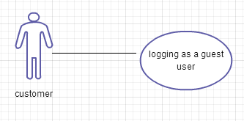

20. Name: Selecting a different language on the start screen

Actors: Customer, Customer Interface

Entry Condition: The system is displaying the welcome screen

Flow Event:

1. The customer presses the button that corresponds to their preferred language.

2. The system changes all interface text to the text in the corresponding language pack.

Exit Condition: The system is displaying the user’s preferred language.

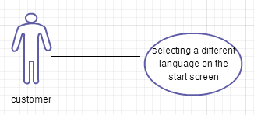

21. Name: Retrieve favorite sandwich

Actor: Customer

Entry Condition: Customer has logged into loyalty account and wants to retrieve favorite sandwich

Exit Condition: Customer has pulled their favorite sandwich into their order

Event flow: 1. Customer selects their favorite sandwich.

2. The system loads their sandwich onto their current order

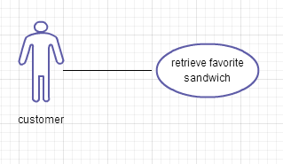

22. Name: Pay with Cash

Actor: Customer

Entry Conditions: Customer’s order is completed.

Customer puts cash into the “vending machine”

Exit Conditions: Customer pays for an order with cash

Event flow: Customer pays for an order with cash

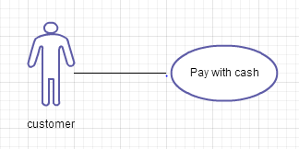

23. Name: Print loyalty card

Actors: Customer

Entry Conditions: Customer has just created a new account

Post Conditions: Loyal card for the customer has been printed

Event flow:

1. Customer has finished entering account details

2. Customer enters create account

3. System prints out the loyalty card

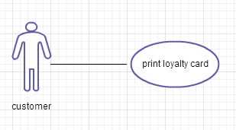

24. Name: Checkout order

Actors: Customer

Entry Conditions: Customer has an order they are satisfied with

Exit Conditions: Customer’s order is finalized into the system

Event flow:

Customer clicks on checkout order.

